|  |  |
| --- | --- |
| **DATE** | **07 November 2022** |
| **TEAM ID** | **PNT2022TMID26051** |
| **PROJECT NAME** | **Smart Crop Protection System for Agriculture** |
| **MAXIMUM MARKS** | **20 marks** |

|  |  |  |  |  |  |
| --- | --- | --- | --- | --- | --- |
| SPRINT-2 | US-1 | Configure the connection security and create API keys that are used in the Node-RED service for accessing the IBM IoT Platform | 10 | High | G Poojitha Naidu  K pravalika  S Bhavana  G shamitha Reddy |
| SPRINT-2 | US-2 | Create a Node-RED service | 10 | High | G Poojitha Naidu  K pravalika  S Bhavana  G shamitha Reddy |

* Configure the connection security and create API keys that are used in the Node-RED service for accessing the IBM IoT Platform.

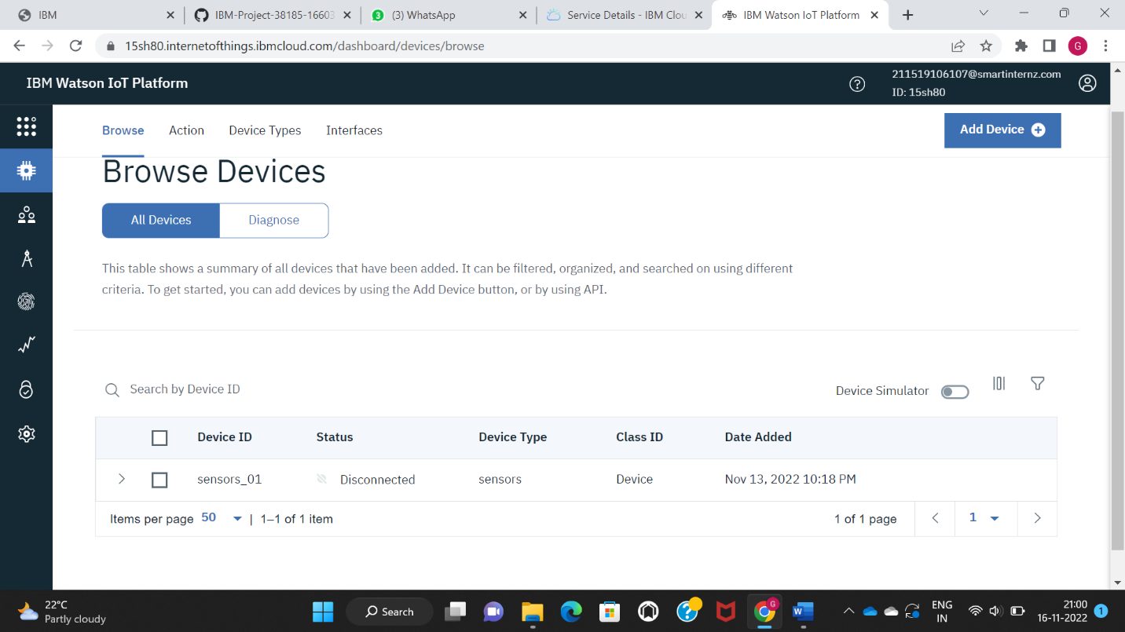

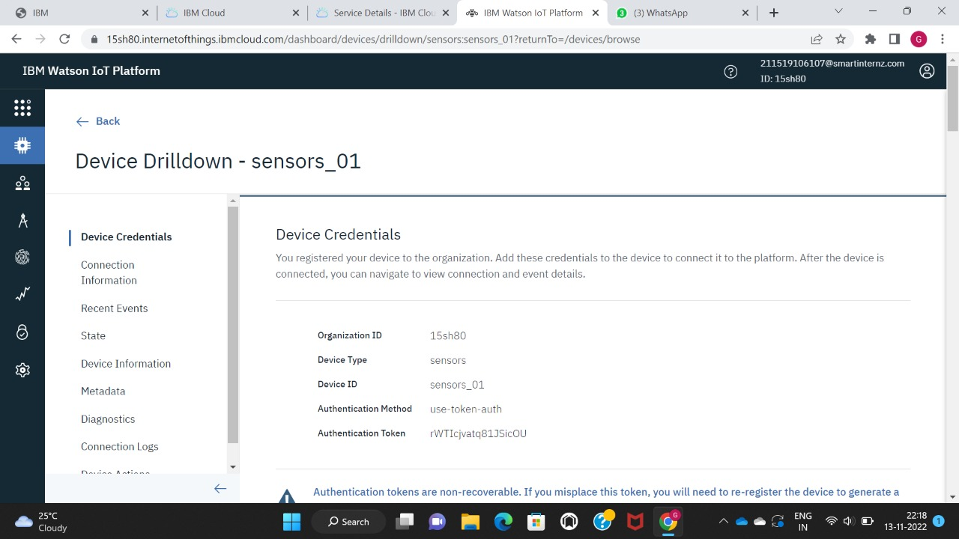

**Download and install node js**

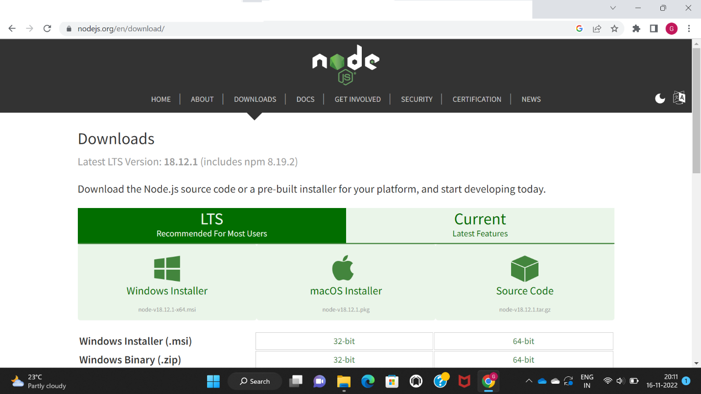

* Create NODE-RED service:

